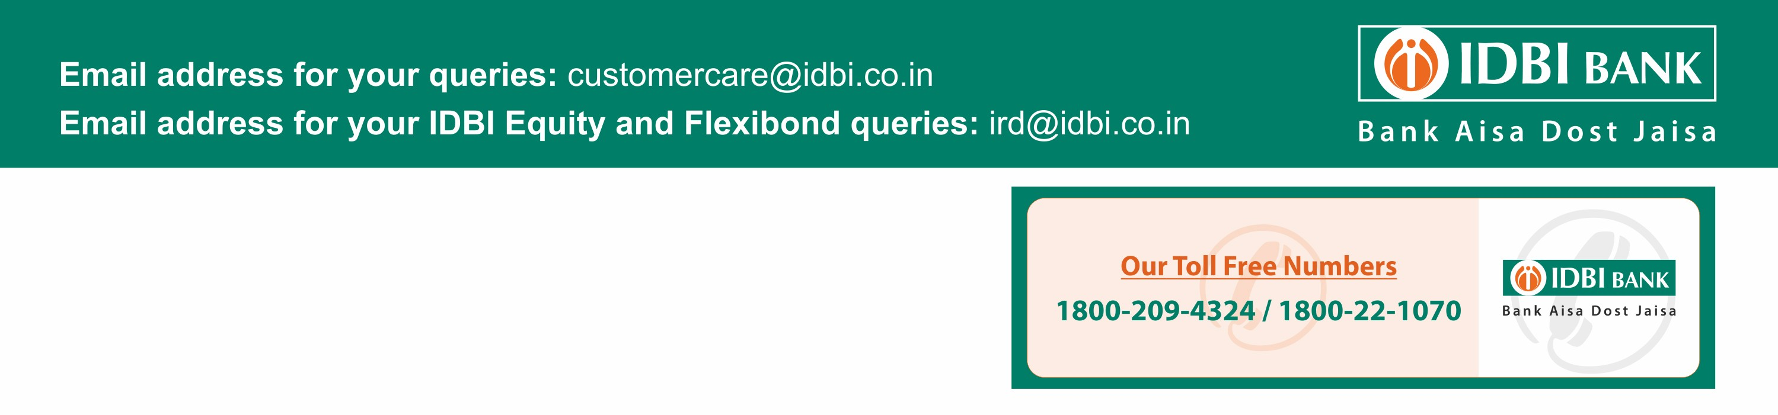

**Primary Account Holder Name : AMIT MANOJBHAI JOSHI**

Address : YASH TECHNOLOGIES, TOWER: 1, A & B WING, CYBERCITY, MAGARPATTA CITY HADAPSAR - PUNE MAHARASHTRA INDIA - 411028

Account No : 0102104000100779

Customer ID : 72966320

Account Branch : Pune-Hadapsar- (Sol -102)

Nominee Registered : : Yes

YOUR A/C STATUS

# Transaction Date From :

01/04/2023

to: 31/03/2024

A/C NO: 0102104000100779

|  |  |  |  |  |  |  |  |  |  |
| --- | --- | --- | --- | --- | --- | --- | --- | --- | --- |
| **Srl** | **Txn Date** | **Value Date** | **Description** | | **Cheque No** | **CR/DR** | **CC Y** | **Amount (INR)** | **Balance (INR)** |
| 1 | 05/04/2022 12:27:05 PM | 05/04/2022 | IPAY/INST/NEFT/213516909/30565890738 MINA | |  | Dr. | INR | 40,000.00 | 0.00 |
| 2 | 05/05/2022 01:29:14 PM | 05/05/2022 | IPAY/INST/NEFT/217871673/30565890738 MINA | |  | Dr. | INR | 40,000.00 | 0.00 |
| 3 | 01/06/2022 10:40:55 AM | 01/06/2022 | IPAY/INST/NEFT/221501778/30565890738 | MINA |  | Dr. | INR | 40,000.00 | 0.00 |
| 4 | 03/07/2022 04:07:20 PM | 03/07/2022 | IPAY/INST/NEFT/226384457/30565890738 | MINA |  | Dr. | INR | 40,000.00 | 0.00 |
| 5 | 02/08/2022 07:58:33 PM | 02/08/2022 | IPAY/INST/NEFT/230163571/30565890738 | MINA |  | Dr. | INR | 40,000.00 | 0.00 |
| 6 | 04/09/2022 12:55:22 PM | 04/09/2022 | IPAY/INST/NEFT/234328715/30565890738 | MINA |  | Dr. | INR | 40,000.00 | 0.00 |
| 7 | 03/10/2022 05:50:26 PM | 03/10/2022 | IPAY/INST/NEFT/238702993/30565890738 | MINA |  | Dr. | INR | 40,000.00 | 0.00 |
| 8 | 05/11/2022 03:52:50 PM | 05/11/2022 | IPAY/INST/NEFT/242697409/30565890738 | MINA |  | Dr. | INR | 40,000.00 | 0.00 |
| 9 | 04/12/2022 01:18:08 PM | 04/12/2022 | IPAY/INST/NEFT/247155186/30565890738 | MINA |  | Dr. | INR | 40,000.00 | 0.00 |
| 10 | 01/01/2023 11:59:51 AM | 01/01/2023 | IPAY/INST/NEFT/251431102/30565890738 | MINA |  | Dr. | INR | 40,000.00 | 0.00 |
| 11 | 04/01/2023 09:51:18 AM | 04/01/2023 | IPAY/INST/NEFT/268731406/30565890738 | MINA |  | Dr. | INR | 40,000.00 | 0.00 |
| 12 | 05/01/2023 10:11:12 AM | 05/01/2023 | IPAY/INST/NEFT/269771606/30565890738 | MINA |  | Dr. | INR | 40,000.00 | 0.00 |

Statement Summary:-

|  |  |  |  |
| --- | --- | --- | --- |
| Dr Count | Cr Count | Debits | Credits |
| 12 | 0 | 480000 | 0 |

This is an account statement generated through Net Banking and does not require signature.

Important Information:

Contents of this statement will be considered correct if no discrepancies are reported in writing immediately. Value Date shown is the effectivedate for Debit and Credits in the account.Balance shown includes

debit, credit, overdraft limit, funds under clearing and does not include the amount marked as lien. Therefore the available balance may differ from the balance displayed in the account statement.

DO NOT reply to any fraudulent phishing emails purportedly sent by IDBI Bank or other authorities asking for your Login ID, Password(s), OTP, OSP, URN or your account details etc. for updation or for any other

reason. Please beware of such fraudulent mails, asking you to provide or update such information on a website or by clicking on a link within the email. We take your personal information seriously and will never

ask for details about your Account / PINs or Passwords over the email/SMS/ Phone calls. The Bank is not responsible for any fraudulent transactions due to compromise or inadvertent disclosure of account related

information.

Service Tax Registration No:AABCI8842GST001. Classifications of service: Banking and Financial services Chargeable services include service tax @14% (including education cess and higher education cess)

# IDBI Bank Ltd. Regd. Office: IDBI Tower, WTC Complex, Mumbai 400005. [Website:www.idbi.com](http://www.idbi.com/)

Our Toll-free numbers are: 1800-22-1070 & 1800-200-1947. Chargeable number: 022-66937000. For Blocking of Debit Card Contact on: 1800-22-

Page 1 of 1